Mech 200 Design Project #2 (Fall 2020)

Hydraulic Cylinder

Specifications:

* Available pressure: 10 MPa
* Pushing force: 10 kN
* 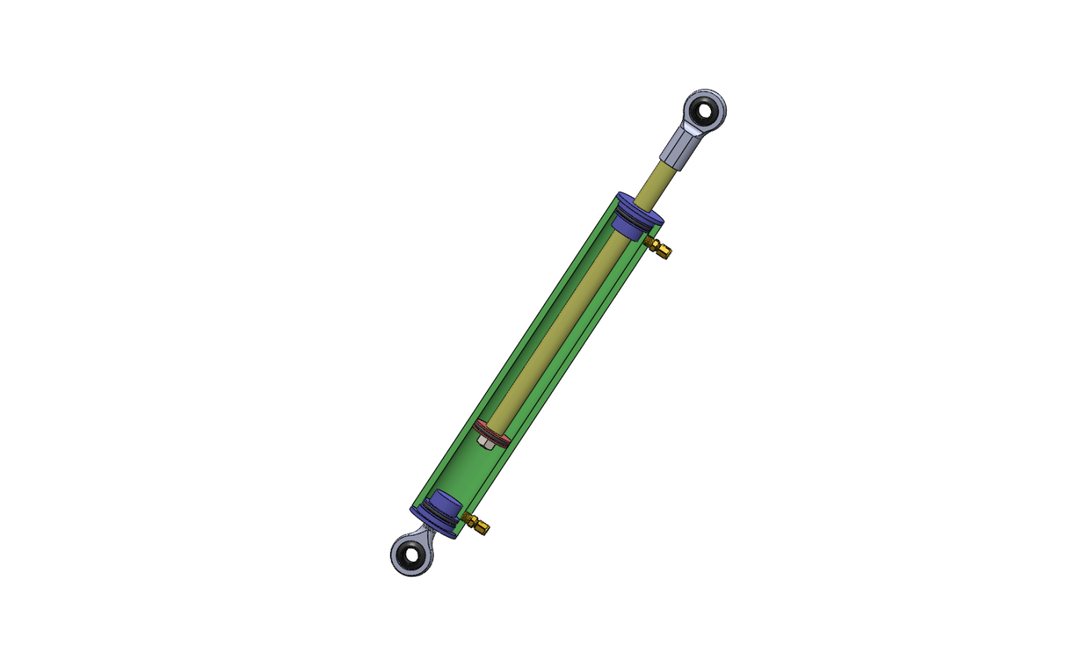Pulling force: 7 kN
* Stroke: 250 mm
* Rod ends at both ends, similar to McMaster Carr 60645K621
* Hose Connection: 3/8” NPT, similar to McMaster Carr [52245K824](http://www.mcmaster.com/#52245K824)

Resources:

* Parker Hannafin O-Ring Tolerance Manual
* Maryland Metrics thread data charts
* McMaster Carr part downloader
* “How It’s Made” Hydraulic Cylinder

Deliverables:

* Assembly drawings /30
* Dimensioned part drawings with tolerances /50
* Bill of materials /10
* Calculations /10
  + Neatness and readability 3/10
  + Accuracy 7/10

Additional Info:

* Project #2 is to be completed in **SolidWorks**
* Please keep in close contact with your respective TA who will guide you through the early stages of the design process
* Please show the design calculations to your TA **BEFORE** proceeding to the drawing phase. You must also supplement your design calculations and design concepts with sketches (that you can use as discussion points with your TA)
* If you have handwritten calculations, you MUST scan it with high quality
* You may have your calculations in Word
* ALL the drawings MUST be made in INCHES
* Submission Due date: Nov. 9, 2020
* You (each group) must submit your project in brightspace to your TA.

Report Format:

* Cover page: Group member names, student numbers and group number (i.e. A05)
* Page 1: Design calculations (and free body diagrams)
* Page 2: Design calculations (and free body diagrams)
* Page 3: Bill of materials (table form)
* Page 4: Assembly drawing
* Page 5: Detailed part drawings
* Page 6: Detailed part drawings
* Page 7: Detailed part drawings
* Page n: Detailed part drawings